# 03. Great Britain

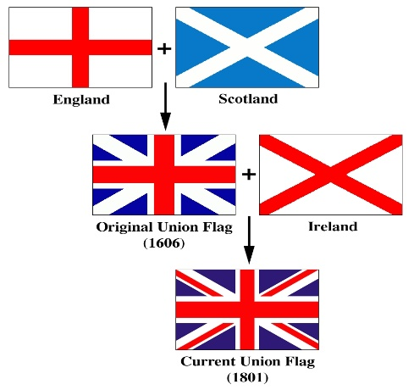Capital of England is London.

Capital of Scotland is Edinburgh.

Capital of Wales is Cardiff.

UK contains of:

Great Britain (England, Scotland, Wales)

Northern Ireland with capital city Belfast

Britain is just England and Wales!!

## Geography

The north-western coast of Europe

Highest mountain: Ben Nevis (1343m)

The English Channel (la Manche) – channel between France and the UK

The Irish Sea – separates GB from Ireland

Rivers: the Thames, the Severn, the Avon, the Clyde, the Mersey

## Climate

Mild, no extreme temperatures, cold summers

## Important Cities

London – the Tower of London, the Tower Bridge, Buckingham Palace, Trafalgar Square

Oxford – oldest university in the UK

Stratford upon Avon – Shakespeare birth place

Stonehenge – group of huge stones; no one knows where they come from

Liverpool – the Home of Beatles, major seaport

Edinburgh – historic city, medieval castle

## Political System

Constitutional Monarchy

Parliament: Queen (Elizabeth II – since 1952), the House of Common (lower) and the House of Lords (upper)

## People, languages

Population: 60 million people (English, Scottish, Welsh, and Irish)

Languages: English, Welsh, Gaelic

## Other

Anthem: God save the Queen

Flag: called the Union Jack; combining three crosses – English, Scottish and Irish